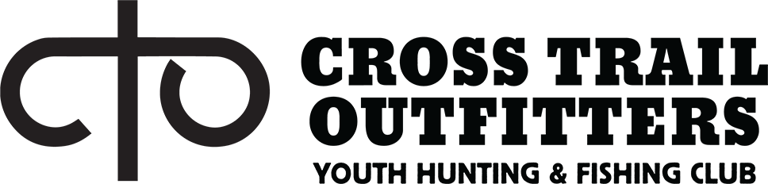
Health Screening Form

We are grateful for your partnership with us to provide a safe and healthy environment for our kids. This completed form is required for check-in at Cross Trail Outfitters events.
Youth Participant or Volunteer’s Name:

Participants Date of Birth: CTO EVENT & Date:

- Has your child experienced any of the following symptoms in the 2 weeks: (Please Circle) Yes or No

  - fever or chills
  - cough
  - shortness of breath or difficulty breathing
  - fatigue
  - muscle or body aches
  - headache

MY CHILD HAS BEEN SYMPTOM FREE FOR THE PAST 14 DAYS
- new loss of taste or smell
- sore throat
- congestion or runny nose
- nausea or vomiting
- diarrhea
INITIAL HERE

- Within the past 14 days, has your child or household been in close physical contact (6 feet or closer for at least 15 minutes) with a person who is known to have laboratory-confirmed COVID-19 or with anyone who has any symptoms consistent with COVID-19? (Please Circle) Yes or No
- Is your child or household self-isolating or quarantining because you may have been exposed to a person with COVID-19 or are worried that you may be sick with COVID-19? (Please Circle) Yes or No
- Is your household or child currently waiting on the results of a COVID-19 test? (Please Circle) Yes or No
I VERIFY THAT I HAVE ANSWERED THE ABOVE QUESTION TRUTHFULLY
INITIAL HERE

The health and safety of our participants is our #1 priority. In light of the COVID-19 pandemic, we think it is important that you understand our efforts to manage your youth participants’ health and safety so that you can make an informed choice. We are focused on taking all reasonable measures to prevent the spread of COVID-19 on our outings and events. We have strengthened our standard cleaning procedures, while adding increased frequency measures for things such as wiping down common touch points and activity equipment. Additionally, we have taken measures to monitor and address symptomatic kids and volunteers by introducing this pre-camp health screener, daily temperature checks, and protocols to isolate, confirm, respond, and remove any camper or staff with suspected COVID-19. This situation continues to change daily, and as such, we will adapt and adjust our protocols and procedures as we follow the guidance provided by the CDC and local health departments, in our efforts to help keep our youth participants, volunteers, staff, and families safe. Ultimately, the choice for your child to attend Cross Trail Outfitter's events is a personal one, and you are in control. If you are uncomfortable with the risks of COVID-19 in a camp setting, having to travel to one of our locations, or having your child interact with our staff and other youth, we have several options available to you, including a full refund or applying the funds towards your child's CTO account to use towards future CTO events.
I CONSENT TO THE ABOVE DISCLOSURE
INITIAL HERE

Participant or Parent/Guardian Signature: Date:

