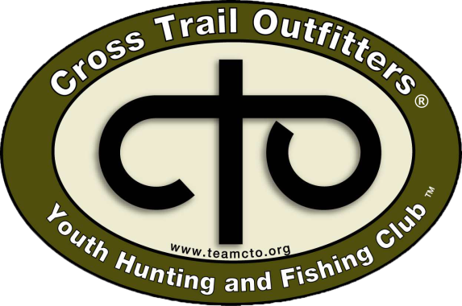

We are grateful for your partnership with us. To provide a safe and healthy environment at our CTO activity we ask that you complete this COVID 19 form. Please complete the information listed below for it will be required for check-in at all CTO Sportsman / Family Day Activities and should be completed prior to your child’s arrival.
Participants Name: _______________________________________________________
Date of Birth: _____________________ CTO Activity: __________________________

Daily Temperature Check
As part of your partnership with us, for seven days prior to your child’s arrival at a CTO Sportsman Day / Family Day Activity, all participants must record their temperature. For your convenience, we’ve provided spaces below and recommend you check and record your child’s temperature at the same time each day.
Day One | Day Two | Day Three | Day Four | Day Five | Day Six | Day Seven

My Child has been fever free for the past seven days: (Initial here) (_________)

Symptoms in the Last 14 Days
( ) Fever (above 100.4 F) ( ) Change in Taste or Small
( ) Cough ( ) Change in Appetite
( ) Shortness of Breath ( ) Generally Not Felling Well
( ) Body Aches

My Child has been symptom free for the past 14 days: (Initial here) (_________)

Pre-Existing Illness
( ) Cardiovascular Disease (including Hypertension)
( ) Diabetes
( ) Chronic Respiratory Disease (including asthma)
Individuals with preexisting conditions such as cardiovascular disease, diabetes, and chronic respiratory disease including asthma are at an increased risk of severe illness id COVID-19 is contracted. I understand that my child’s pre-existing illness increases the implied risk of COVID-19

I understand the implied risk of Pre-Existing Illnesses (initial here) (________)

Contact History
Check any that apply:
( ) The individual has been diagnosed with COVID-19
( ) This individual has a close contact that has been in contact with someone exposed to or infected with COVID-19 in the last 14 days
( ) The individual has a household member currently on a watch list for COVID-19 exposure.

I verify that I have answered this question truthfully (initial here) (________ )

The health and safety at our CTO Sportsman Day / Family Day Activities is our #1 priority. In light of the COVID-19 pandemic, we think it is important that you understand our efforts to manage each participants health and safety so you can make an informed choice. We are focused on taking all reasonable measures to prevent the spread of COVID-19 at all CTO Activities. We have strengthened our standard cleaning procedures, while adding increased frequency measures for things such as wiping down common touch points, dining hall areas and activity equipment. Additionally, we have taken measures to monitor and address symptomatic participants by introducing this pre-outing health screener, daily temperature checks and protocol to isolate, confirm, respond and remove any participant or staff with suspected COVID-19.
This situation continues to change daily, and as such, we will adapt and adjust our protocols and procedures as we follow the guidance by the CDC and local health departments in our efforts to help keep each participant, staff and families safe.
Ultimately the choice for your child to attend a CTO Sportsman Day / Family Day Activity is a personal one, and you are in control. If you are uncomfortable with the risk of COVID-19 at an outing setting, having to travel to our location or having your child to interact with our staff and other participants, we suggest you do not send your child to our Sportsman Day / Family Day Activity.

I consent to the above disclosure for the CTO Sportsman Day / Family Day Activity.
(Initial Here) (_______)

Parents Signature Date

